June 2021

Guidance Note
Terms of Reference for Local Education Groups

Mandated by national governments, local education groups usually include the creation of a formal terms of reference (TORs) or the equivalent such as Memorandum of Understanding or partnership framework. Such documents serve to formalize the multi-stakeholder forum for dialogue and coordination and articulate its relationship to the country’s education sector. They also outline and communicate to its members and the wider education community what the forum does (its goals and functions), and its composition, governance and working arrangements, as well as arrangements for review and learning.

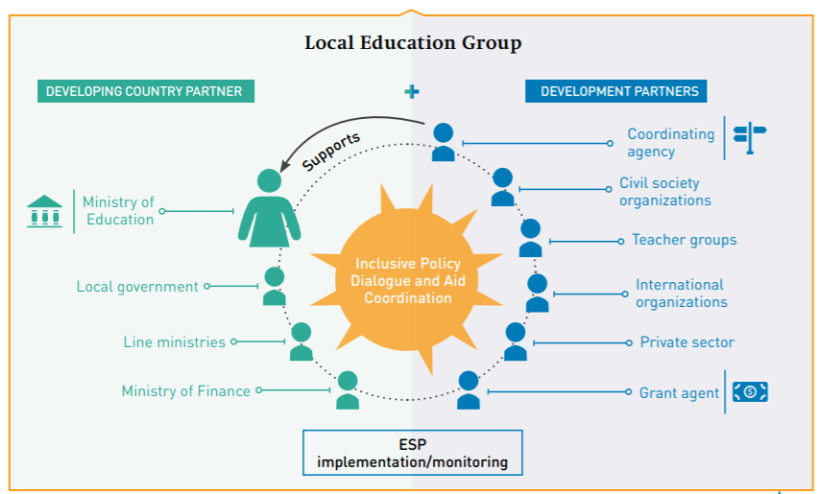

Note to user

This brief guidance note offers a template supporting the elaboration, strengthening, or review of LEG Terms of Reference, whether the LEG is new or more experienced. The sections and related question-prompts suggest issues for consideration based on the Principles toward effective local education groups and what other country partnerships have included in their Terms of Reference (Ref: Repository of Practices - country examples of TOR). The template can be aligned with, or used independently of, a LEG Self-Assessment exercise.

Not all questions in each section need to be answered, although a minimum level of detail is recommended to communicate the value of the LEG through its TORs. The sequence of sections is also indicative for the purpose of guidance and can be different in the resulting ToR. As country circumstances and contexts are continuously evolving, it may be deemed useful to review the TORs every few years as needed.
GUIDING TEMPLATE

Date: [when terms of reference written/revised].

Title: Terms of reference for [name of the Local Education Group]

Introduction

The introduction should briefly articulate the country context, the LEG mandate and specific purposes/objectives, as well as any mutually agreed upon principles and values guiding the partnership. The LEG mandate should ideally be situated in relation to the national education sector, including other policy dialogue fora. The strategic value of the LEG (or dialogue functions at the heart of the LEG’s mandate) should be clearly identified, including the extent and limitations to its decision-making powers.

Context and mandate
- When was the LEG established, and by whom?
- What is the dominant education sector context, policy frameworks and development plans within which the LEG operates?
- What is the mandate/authorities of the LEG in relation to national education policy and sector plans? Does it have consultative and/or decision-making powers?
- Do organizations exist with a similar mandate? If so, are mechanisms in place to harmonize efforts?

Strategic value - purpose, functions
- What is the LEG’s value proposition? i.e. what types of policy dialogue and joint action are central to its purpose and offer value to education systems?
- How are partner assets leveraged in realizing this value?

Member values and behaviours
- What are the values and commitments that LEG members adhere to? i.e. inclusive dialogue, mobilizing resources, harmonized action, alignment, mutual accountability etc.
- Are specific behaviors and values expected from members? i.e. trust, reciprocity, collegiality, equality, fairness, transparency etc.

Composition and membership

The LEG’s composition and membership eligibility embed the principles of inclusiveness, equality, diversity and gender balance. Equally important, all categories of stakeholders and constituencies should know what is expected of their participation in the LEG to improve the quality of their inputs. If necessary, specific annexes can be developed describing the eligibility of the different LEG working groups (core, thematic, technical) and the specific roles and responsibilities.

Composition and membership eligibility
- Who is membership of the LEG membership open to?
- Are there any eligibility criteria/restrictions on numbers for the core and LEG working groups?
- Are there any rules of rotation for different categories of stakeholders (e.g. for leadership actors)?
- How long is the period of membership for? i.e. is it permanent, or for a fixed time period?
- Do protocols for exit from the LEG exist?
- Will non-members be invited to collaborate in LEG activities; under what circumstances?

Membership responsibilities
- What are the expectations towards members? Will they have responsibilities in addition to their attendance at meetings (i.e. related to information exchange prior to meetings, reporting on actions taken, rotating support to coordination etc.)?
- Who will facilitate adhesion to these commitments?

Governance arrangements

The TOR should clarify what the main LEG governance roles are and who is responsible, including any cross-over between the LEG core and working groups and between national and sub-national levels. Articulating LEG governance roles and arrangements will embed understanding of decision-making authorities and powers (including as LEG Chair, Co-Chair, Coordinating Agency).

Governance structure
- What is the structure of the LEG (i.e. does it have a core group, thematic or technical working groups)?
- Are there any differences in membership between the LEG core & thematic/technical sub-groups based on stakeholder constituencies?
- What are the authorities, roles and decision-making powers for each of these groups and the relationship between them?

Leadership
- Who will undertake LEG governance roles and responsibilities (chair, co-chair, coordination or oversight of working arrangements etc.)?
- If not assigned as a co-chair, what will be the role of the coordinating agency in the LEG?
- Consider rotation arrangements.

Linkages to other governance levels
- Will efforts be made to distribute governance arrangements with sub-national levels?
- Have any special protocols been foreseen to ensure flexibility in governance arrangements in low capacity countries and in situations responding to crisis and emergencies?

Working arrangements

The LEG’s working arrangements are the organizational backbone of how it functions and therefore impact on the quality of policy dialogue and stakeholder participation in joint action. To this end, the TOR should clearly articulate how the LEG operates in practical terms and who is responsible for what? Some of these details can be specified in Annexes. Additional details can also be added as the LEG evolves or as part of its regular review.

Capacitates for arrangements

- Is a Secretariat or similar entity foreseen for the general day-to-day coordination of the LEG’s convening work with responsibilities for: facilitating the meeting agenda of the different LEG groups; organizing meetings; timely dissemination of supporting information; following up on agreed action points; general communications, organizing regular reviews? Where will it be located?
- Which actors are otherwise responsible for these tasks?
- Will secretariat tasks be assigned on a rotating or permanent basis?

Task-related breakdown of working arrangements, roles and responsibilities

Closely related to the above:

Agenda setting
- How will issues for policy dialogue in the different LEG bodies be decided? i.e. through discussion between governance actors during a periodic/annual review, or as a joint consultation process with all LEG members?

Frequency of LEG meetings and follow-up
- How often is the LEG expected to meet during the year (for core and technical / thematic groups)?
- If meetings are held in person, where will they be held (national or sub-national level)?
- Will there be online spaces for LEG members to meet in light of the current Covid-19 context? If so, who will be responsible for facilitating these spaces?

Sharing evidence, information and resources
- Are regular internal communications foreseen to keep LEG members aware of the dialogue agenda and joint actions throughout the year (e.g. to generate clarity on timing and expected stakeholder inputs to the core & thematic/technical groups, and transparency in decision making)?
- Will a knowledge management plan be created to share core documents and facilitate information exchange among members within different groups? Which actors are responsible for its management?
- Are LEG leadership actors expected to report back on group activities to the broader membership?

External advocacy and communications
- Who is responsible for general advocacy and communications around the LEG’s progress in realizing its goals (i.e. related to sector dialogue and joint actions)?

Review and learning

Regular review helps the LEG leadership and education stakeholders to understand whether the LEG is making progress towards its agreed policy dialogue goals, and whether governance and working arrangements are fit-for-purpose or require adjustment in light of the evolving context to enhance effectiveness. The aims of a review can be achieved as part of broader sector reporting mechanisms, such as joint sector review processes, or through a regular self-assessment.

Review related to LEG’s strategic functions
- How often will the LEG review and draw learning around progress and value related to policy dialogue objectives and joint actions?
- Who will facilitate and participate in the review?

Review of LEG organizational and collaborative capacities
- Will there be a regular review of the LEG’s governance structure, working arrangements and partnership culture to identify its strengths and bottlenecks to efficiency, so as to ensure a continuum of improvement and meet stakeholder interest and expectations?

Annexes

The LEG can provide more in-depth details on elements in the TOR through annexes, including:

  - Criteria for membership and/or membership list
  - TOR for subgroups/thematic groups (if relevant)
  - Breakdown of tasks for different actors (related to governance or working arrangements)
  - Organigram of sector dialogue and coordination structures
  - Conflict of interest arrangements
  - References to any key resources for LEG members
  - Other…

List permanent, rotating, or potential ad-hoc members.
In practical terms, and to support meaningful engagement and efficient membership, it is useful to articulate the difference between membership of the LEG’s core sector-related dialogue group and technical/thematic working groups, as well as any differences between permanent and ad-hoc membership. This will help to avoid an overly large representation of stakeholders in different meetings that may undermine the quality of policy dialogue and meeting efficiency.
*If different categories of stakeholders have been assigned specific responsibilities in relation to the LEGs working arrangements, these should be outlined in an Annex.

